**IDIVE TRIPS (Front)**

**BROWSER- Internet Explorer**

**DATE- 19/03/2014**

|  |  |  |  |  |  |  |  |  |  |
| --- | --- | --- | --- | --- | --- | --- | --- | --- | --- |
| **Test Case ID** | **Module** | **Features** | **Objectives** | **Step/User Action** | **Expected Result** | **Actual Result** | **Status** | **Developer Comment** | **Tester Comment** |
| TC 01 | Login | Functionality | To validate the functionality of “Terms & Conditions” link | 1. Enter the URL **http://infranix.net/idive**  2. Click on the **Create an Account** link mentioned on the top right side of the page  3. Click on the **Terms & Conditions** link mentioned under the last field | 1. User should be redirected to the Homepage  2. **Sign Up** page should be appear  3**.** User should be redirected to the **“Terms & Conditions”** page | 1. User is redirected to the Homepage  2. **Sign Up** pageis appearing  3. **“Terms & Conditions”** link is not working | Done |  |  |

**Snapshot Attached-**

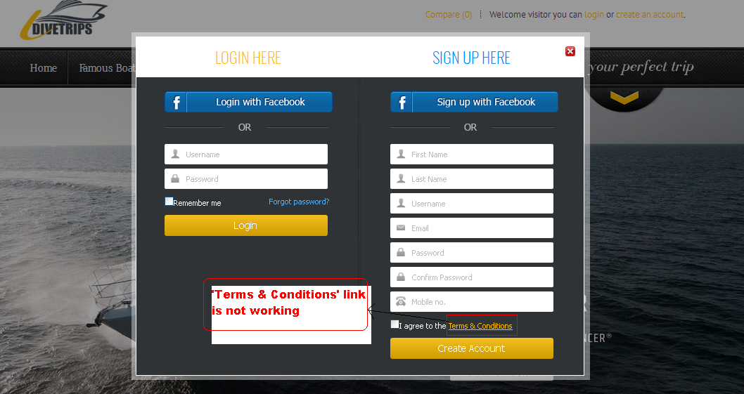

|  |  |  |  |  |  |  |  |  |  |
| --- | --- | --- | --- | --- | --- | --- | --- | --- | --- |
| **Test Case ID** | **Module** | **Features** | **Objectives** | **Step/User Action** | **Expected Result** | **Actual Result** | **Status** | **Developer Comment** | **Tester Comment** |
| TC 02 | Our Trips | Functionality | To validate the functionality of **Add Your Reviews** link | 1. Enter the URL **http://infranix.net/idive**  2. Click on the Header menu **“Our Trips”**  3. Click on the **View Detail** button mentioned for the respective Trips  4. Click on the **Add Your Reviews** link | 1. User should be redirected to the Homepage  2. User should be redirected to the **“Our Trips”** page  3. View Detail page should be opened  4. Review page should be opened for adding the Review | 1. User is redirected to the Homepage  2. User is redirected to the **“Our Trips”** page  3. View Detail page is opened  4. **Add You Review** link is not working | Done |  |  |

**Snapshot Attached-**

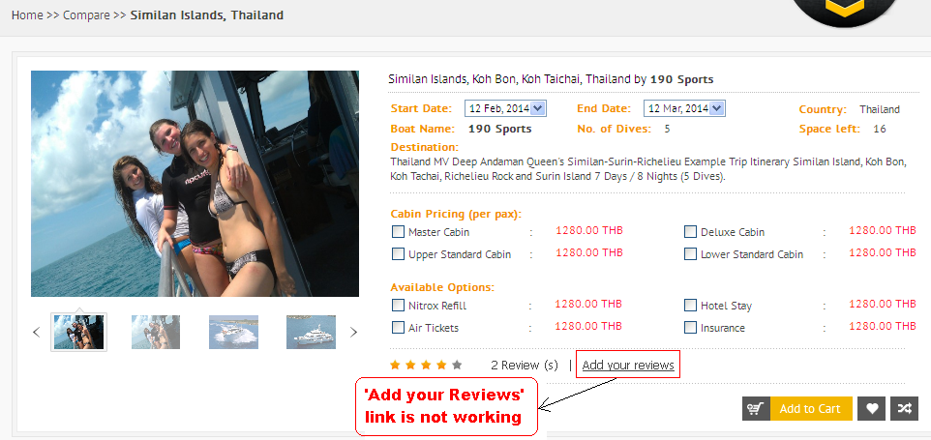

|  |  |  |  |  |  |  |  |  |  |
| --- | --- | --- | --- | --- | --- | --- | --- | --- | --- |
| **Test Case ID** | **Module** | **Features** | **Objectives** | **Step/User Action** | **Expected Result** | **Actual Result** | **Status** | **Developer Comment** | **Tester Comment** |
| TC 03 | My Account | Functionality | To validate the functionality of **Add To Cart** icon | 1. Enter the URL **http://infranix.net/idive**  2. Click on the **Login** link mentioned on the top right side of the page  3. Enter the valid **Email id** and **Password** and click on the **Login** button  4. Now click on the **My Account** link  5. Click on the **Wishlist** Link  6. Click on the **Add To Cart** icon mentioned under table heading **Action** in the grid | 1. User should be redirected to the Homepage  2. Login page should be appear  3. **Successful Login** message should appear  4. User should be redirected to the  **My Account** page  5. User should be redirected to the  **Wishlist** page  6. Trip should be added to the Cart | 1. User is redirected to the Homepage  2. Login Page is appearing  3.  **Successful Login** message is appearing  4. User is redirected to the  **My Account** page  5. User is redirected to the  **Wishlist** page  6. **Add To Cart** icon is not working | Done |  |  |

**Snapshot Attached-**

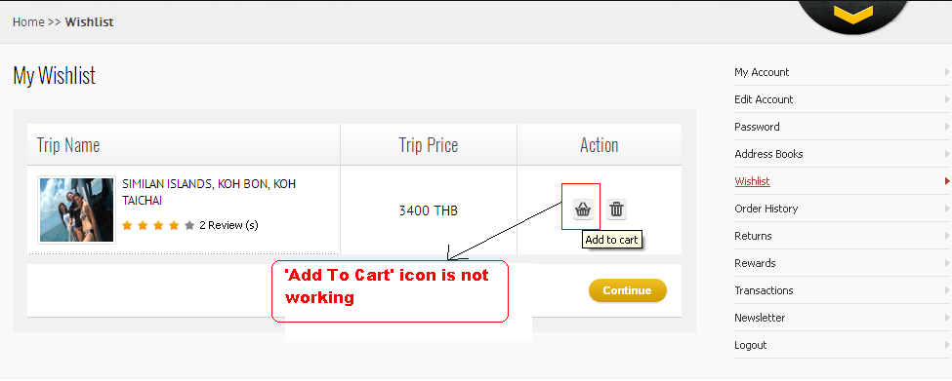

|  |  |  |  |  |  |  |  |  |  |
| --- | --- | --- | --- | --- | --- | --- | --- | --- | --- |
| **Test Case ID** | **Module** | **Features** | **Objectives** | **Step/User Action** | **Expected Result** | **Actual Result** | **Status** | **Developer Comment** | **Tester Comment** |
| TC 04 | My Account | Functionality | To validate the functionality of all the Links mentioned on the page | 1. Enter the URL **http://infranix.net/idive**  2. Click on the **Login** link mentioned on the top right side of the page  3. Enter the valid **Email id** and **Password** and click on the **Login** button  4. Now click on the **My Account** link  5. Click on all the links mentioned on the page | 1. User should be redirected to the Homepage  2. Login page should be appear  3. **Successful Login** message should appear  4. User should be redirected to the  **My Account** page  5. User should be redirected to the respective pages | 1. User is redirected to the Homepage  2. Login Page is appearing  3.  **Successful Login** message is appearing  4. User is redirected to the  **My Account** page  5. **“Order History, Returns, Rewards, Transactions, Newsletters”** links are not working | Done |  |  |

**Snapshot Attached-**

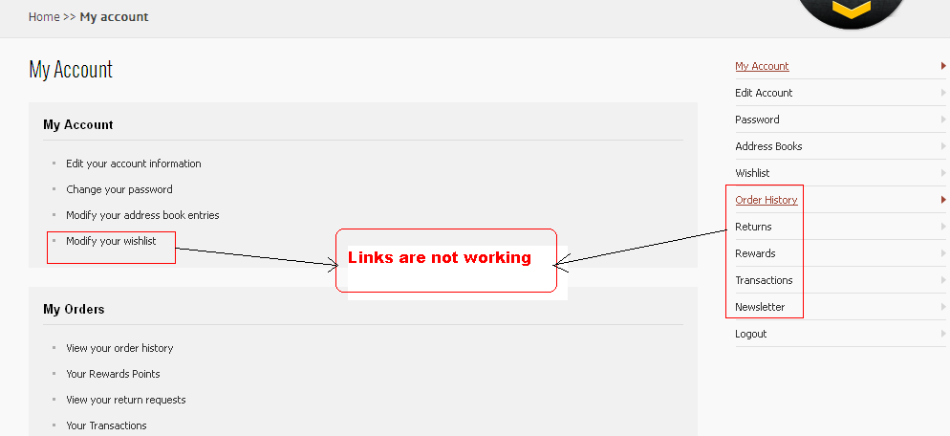

|  |  |  |  |  |  |  |  |  |  |
| --- | --- | --- | --- | --- | --- | --- | --- | --- | --- |
| **Test Case ID** | **Module** | **Features** | **Objectives** | **Step/User Action** | **Expected Result** | **Actual Result** | **Status** | **Developer Comment** | **Tester Comment** |
| TC 05 | My Account | Functionality | To validate the functionality of **Checkout** button | 1. Enter the URL **http://infranix.net/idive**  2. Click on the **Login** link mentioned on the top right side of the page  3. Enter the valid **Email id** and **Password** and click on the **Login** button  4. Place the mouse over the **Shopping Cart**  5. Now Click on the **Checkout** button | 1. User should be redirected to the Homepage  2. Login page should be appear  3. **Successful Login** message should appear  4. **Shopping Cart** pop up should slide down  5. User should be redirected to the **Checkout** page | 1. User is redirected to the Homepage  2. Login Page is appearing  3.  **Successful Login** message is appearing  4. **Shopping Cart** pop up is slide down  5. **Checkout** button is not working | Done |  |  |

**Snapshot Attached-**

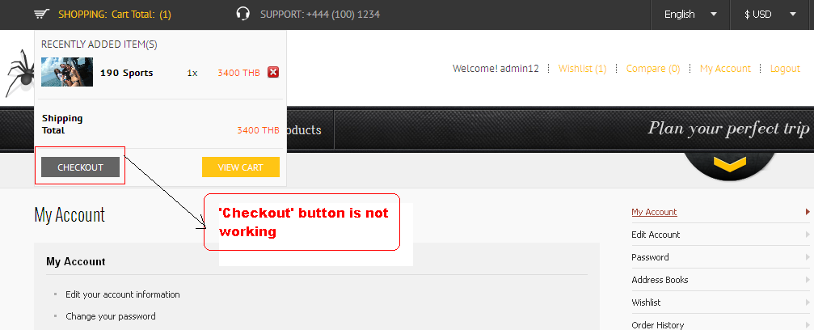

|  |  |  |  |  |  |  |  |  |  |
| --- | --- | --- | --- | --- | --- | --- | --- | --- | --- |
| **Test Case ID** | **Module** | **Features** | **Objectives** | **Step/User Action** | **Expected Result** | **Actual Result** | **Status** | **Developer Comment** | **Tester Comment** |
| TC 06 | My Account | Functionality | To validate the functionality of **Update Your Cart** icon | 1. Enter the URL **http://infranix.net/idive**  2. Click on the **Login** link mentioned on the top right side of the page  3. Enter the valid **Email id** and **Password** and click on the **Login** button  4. Place the mouse over the **Shopping Cart**  5. Now Click on the **View Cart** button  6. Increase the no. of Children in the grid and click on the **Update your Cart** icon | 1. User should be redirected to the Homepage  2. Login page should be appear  3. **Successful Login** message should appear  4. **Shopping Cart** pop up should slide down  5. User should be redirected to the **View Cart** page  6. Total amount should be updated according to that | 1. User is redirected to the Homepage  2. Login Page is appearing  3.  **Successful Login** message is appearing  4. **Shopping Cart** pop up is slide down  5. **View Cart** page is appearing  6. **Update Your Cart** icon is not working properly | Done |  |  |

**Snapshot Attached-**

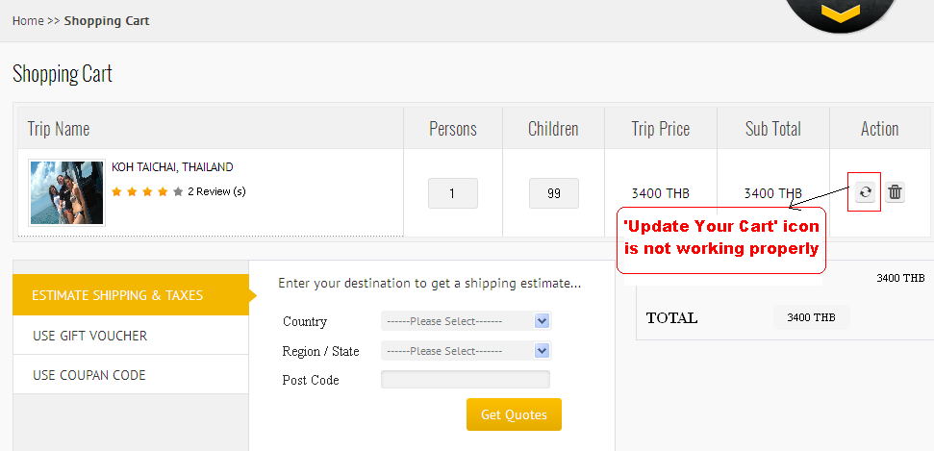

|  |  |  |  |  |  |  |  |  |  |
| --- | --- | --- | --- | --- | --- | --- | --- | --- | --- |
| **Test Case ID** | **Module** | **Features** | **Objectives** | **Step/User Action** | **Expected Result** | **Actual Result** | **Status** | **Developer Comment** | **Tester Comment** |
| TC 07 | My Account | Functionality | To validate the functionality of **Get Quotes** button | 1. Enter the URL **http://infranix.net/idive**  2. Click on the **Login** link mentioned on the top right side of the page  3. Enter the valid **Email id** and **Password** and click on the **Login** button  4. Place the mouse over the **Shopping Cart**  5. Now Click on the **View Cart** button  6. Click on the **Get Quotes** button to get the Shipping Estimate | 1. User should be redirected to the Homepage  2. Login page should be appear  3. **Successful Login** message should appear  4. **Shopping Cart** pop up should slide down  5. User should be redirected to the **View Cart** page  6. User should get the Shipping estimate | 1. User is redirected to the Homepage  2. Login Page is appearing  3.  **Successful Login** message is appearing  4. **Shopping Cart** pop up is slide down  5. **View Cart** page is appearing  6. **Get Quotes** button is not working | Done |  |  |

**Snapshot Attached-**

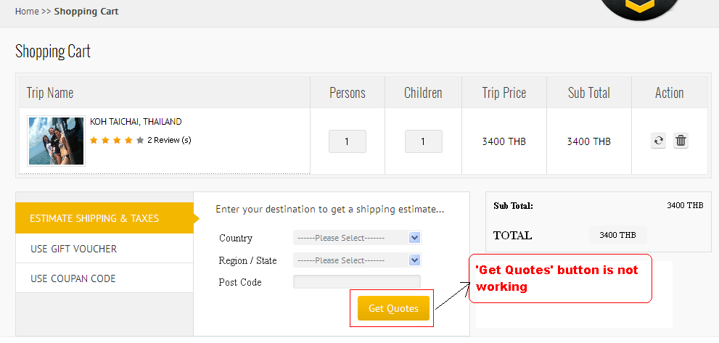

|  |  |  |  |  |  |  |  |  |  |
| --- | --- | --- | --- | --- | --- | --- | --- | --- | --- |
| **Test Case ID** | **Module** | **Features** | **Objectives** | **Step/User Action** | **Expected Result** | **Actual Result** | **Status** | **Developer Comment** | **Tester Comment** |
| TC 08 | My Account | Functionality | To validate the functionality of **Breadcrumbs** | 1. Enter the URL **http://infranix.net/idive**  2. Click on the **Login** link mentioned on the top right side of the page  3. Enter the valid **Email id** and **Password** and click on the **Login** button  4. Place the mouse over the **Shopping Cart**  5. Now Click on the **View Cart** button  6. Click on the **Breadcrumbs** of Shopping Cart | 1. User should be redirected to the Homepage  2. Login page should be appear  3. **Successful Login** message should appear  4. **Shopping Cart** pop up should slide down  5. User should be redirected to the **View Cart** page  6. User should be redirected to the respective pages while clicking on it | 1. User is redirected to the Homepage  2. Login Page is appearing  3.  **Successful Login** message is appearing  4. **Shopping Cart** pop up is slide down  5. **View Cart** page is appearing  6. **Breadcrumbs** are not working correctly | Done |  |  |

**Snapshot Attached-**

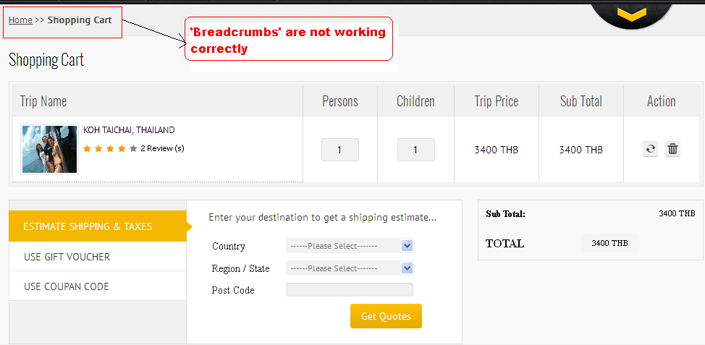

|  |  |  |  |  |  |  |  |  |  |
| --- | --- | --- | --- | --- | --- | --- | --- | --- | --- |
| **Test Case ID** | **Module** | **Features** | **Objectives** | **Step/User Action** | **Expected Result** | **Actual Result** | **Status** | **Developer Comment** | **Tester Comment** |
| TC 09 | My Account | GUI | To verify that the **Checkout** button is mentioned on the page | 1. Enter the URL **http://infranix.net/idive**  2. Click on the **Login** link mentioned on the top right side of the page  3. Enter the valid **Email id** and **Password** and click on the **Login** button  4. Place the mouse over the **Shopping Cart**  5. Now Click on the **View Cart** button  6. Observe the **Checkout** Button on the page | 1. User should be redirected to the Homepage  2. Login page should be appear  3. **Successful Login** message should appear  4. **Shopping Cart** pop up should slide down  5. User should be redirected to the **View Cart** page  6. **Checkout** button should be mentioned on the page | 1. User is redirected to the Homepage  2. Login Page is appearing  3.  **Successful Login** message is appearing  4. **Shopping Cart** pop up is slide down  5. **View Cart** page is appearing  6. **Checkout** button is not mentioned on the page | Done |  |  |

**Snapshot Attached-**

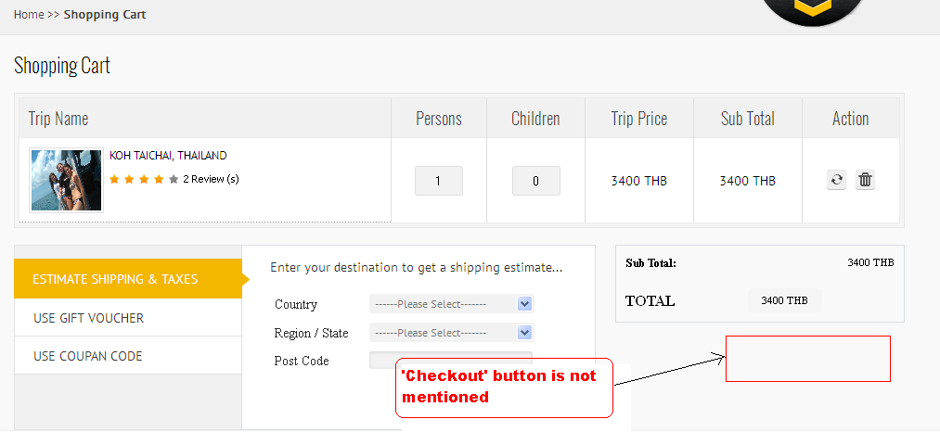

|  |  |  |  |  |  |  |  |  |  |
| --- | --- | --- | --- | --- | --- | --- | --- | --- | --- |
| **Test Case ID** | **Module** | **Features** | **Objectives** | **Step/User Action** | **Expected Result** | **Actual Result** | **Status** | **Developer Comment** | **Tester Comment** |
| TC 10 | My Account | GUI | To verify that the Static texts are spelled correctly | 1. Enter the URL **http://infranix.net/idive**  2. Click on the **Login** link mentioned on the top right side of the page  3. Enter the valid **Email id** and **Password** and click on the **Login** button  4. Place the mouse over the **Shopping Cart**  5. Now Click on the **View Cart** button  6. Read the Static Text mentioned on the page | 1. User should be redirected to the Homepage  2. Login page should be appear  3. **Successful Login** message should appear  4. **Shopping Cart** pop up should slide down  5. User should be redirected to the **View Cart** page  6. Static Text should be spelled correctly | 1. User is redirected to the Homepage  2. Login Page is appearing  3.  **Successful Login** message is appearing  4. **Shopping Cart** pop up is slide down  5. **View Cart** page is appearing  6. Spelling mistake of **“Coupon”** in the menu | Done |  |  |

**Snapshot Attached-**

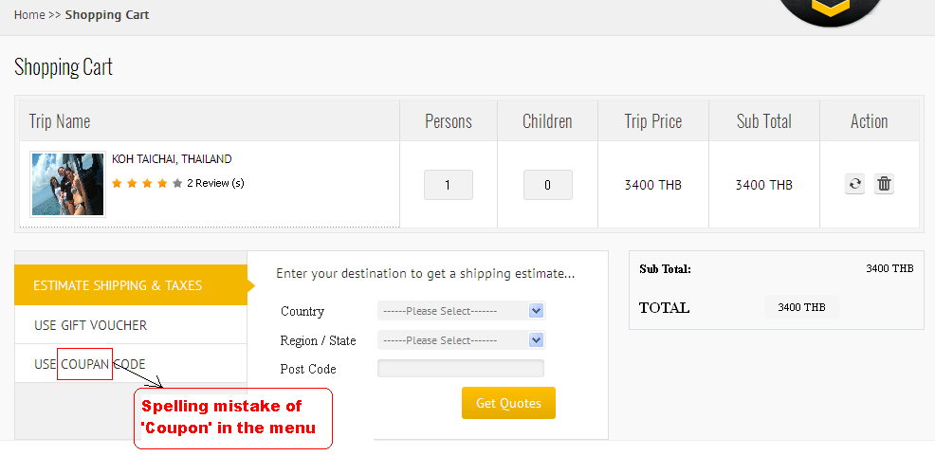

|  |  |  |  |  |  |  |  |  |  |
| --- | --- | --- | --- | --- | --- | --- | --- | --- | --- |
| **Test Case ID** | **Module** | **Features** | **Objectives** | **Step/User Action** | **Expected Result** | **Actual Result** | **Status** | **Developer Comment** | **Tester Comment** |
| TC 11 | Our Trips | GUI | To verify that the Static texts are appearing properly | 1. Enter the URL **http://infranix.net/idive**  2. Click on the Header menu **“Our Trips”**  3. Click on the **View Boat Specification** mentioned for the respective Trips  4. Now observe the **Static Texts** mentioned on the page | 1. User should be redirected to the Homepage  2. User should be redirected to the **“Our Trips”** page  3. **Boat Specification** page should be opened  4. **Static Texts** should be mentioned properly on the page | 1. User is redirected to the Homepage  2. User is redirected to the **“Our Trips”** page  3.  **Boat Specification** page is opened  4. **“Digital 2013 Yachts Catalog” & “Digital 2013 international Boats Catalog”** texts are overlapping in the overview tab | Done |  |  |

**Snapshot Attached-**

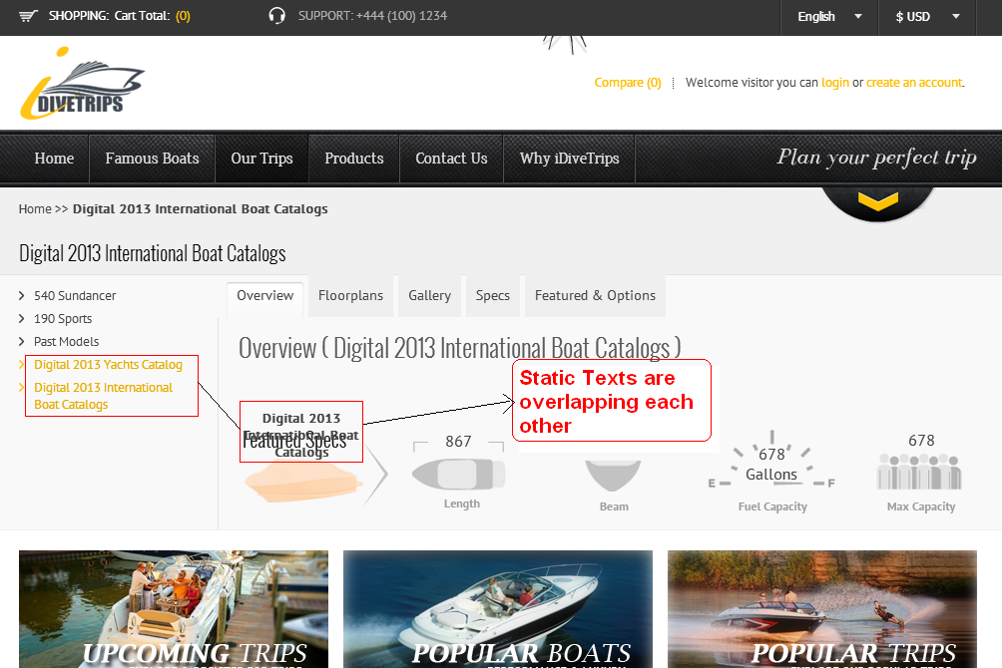

|  |  |  |  |  |  |  |  |  |  |
| --- | --- | --- | --- | --- | --- | --- | --- | --- | --- |
| **Test Case ID** | **Module** | **Features** | **Objectives** | **Step/User Action** | **Expected Result** | **Actual Result** | **Status** | **Developer Comment** | **Tester Comment** |
| TC 12 | Login | Functionality | To verify that the Breadcrumbs are working correctly | 1. Enter the URL **http://infranix.net/idive**  2. Click on the **Create an Account** link mentioned on the top right side of the page  3. Click on the **Forgot Password** linkmentioned under the Login block  4. Now Click on the Breadcrumb **“Forgot Password”** | 1. User should be redirected to the Homepage  2. Registration pop up should be appear  3.User should be redirected to the **Forgot Password** page  4. Usershould remain on the same page | 1. User is redirected to the Homepage  2. Registration pop up is appearing  3.  User is redirected to the **Forgot Password** page  4. **“Forgot Password”** breadcrumb is not working correctly, It is redirecting to the **Change Password** page which is not correct | Done |  |  |

**Snapshot Attached-**

